Automate Full Stack Application (MERN)
Project 01
Setup Environment
- After creating project folder I create a client and server folder for frontend and backend
- Then I go to server folder using cd server and install npm init -y for initialize node project
- After that I run npm install express mongoose cors dotenv those are the dependencies I want
- Express is like the engine of your backend. It helps your Node.js app handle requests and responses easily.
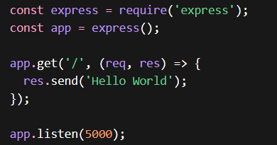

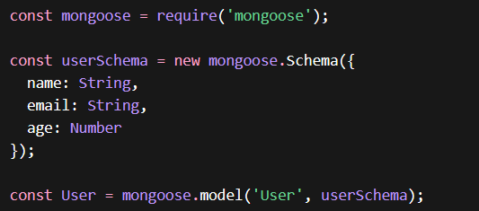
- Mongoose is a tool to talk to MongoDB in a structured way. ODM = Object Data Modeling → it lets you define schemas for your data, so your database knows what “shape” your data should have

- .env file stores secrets or configs separately from code, like API keys, DB URLs, or port numbers.
require('dotenv').config(); - must import env file like this in server file

- CORS = Cross-Origin Resource Sharing
Browsers block frontend code (React) from calling a backend on a different port/domain unless you allow it.

- After that I create models folder inside server folder and inside it I create user.js file for
MongoDB. It tells MongoDB what a user looks like (name, email, age)

- Then I create a routes folder inside sever folder and create routeUser.js file and its
- Take the data from frontend
- Create a new user object
- Save it in MongoDB
- Send a response back

Frontend Setup (Client)
- After go to clint folder I run npx create-react-app . for install react inside folder
- Then I run npm start
- Then I setup app.js file
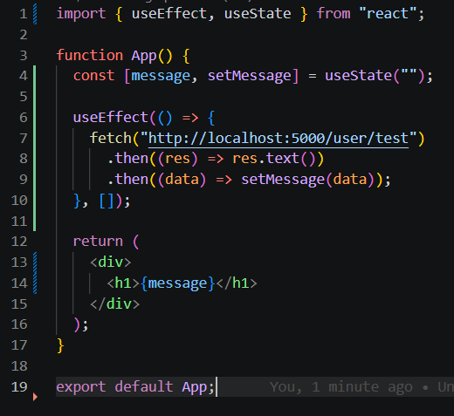

- import { useEffect, useState } from "react";
- useEffect means Runs code automatically when page loads.
- useState means Stores data inside UI.
- I designed UI sepratly so then I can maintain UI easily and connect it to main file (app.js)

Backend Setup (Server)
- In backend specially I created model folder and inside it I create task.js file. Its mainly focused what is structure of data I enter
- And also I create route folder inside it I created taskroutes.js file inside it. Its mainly focused on about routes. When I send request to backend (server.js) its find routes in taskroutes.js file then after connect mongodb, update database and give response back to the clint
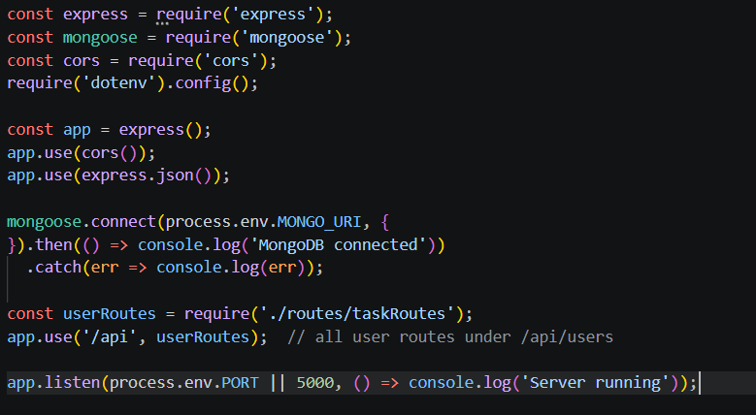
Figure 01: Server.js file

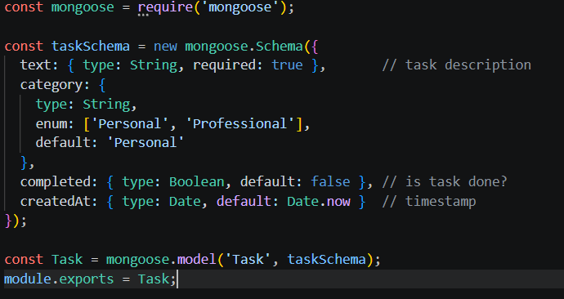
Figure 02: Task.js
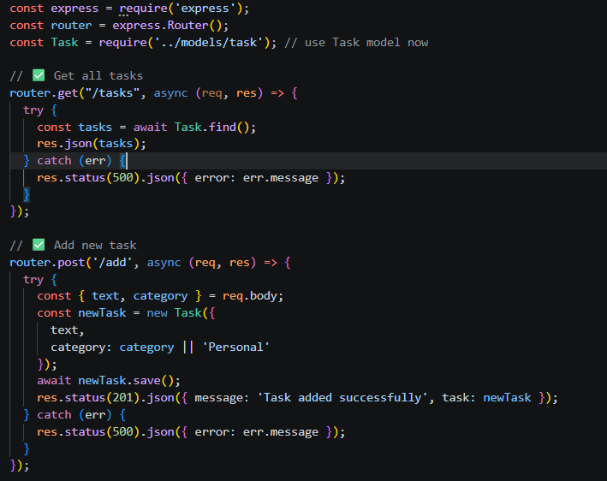
Figure 03: Routestask.js file (half a code)
Docker Containerzation
- 1st of all I created dockerfile inside client folder
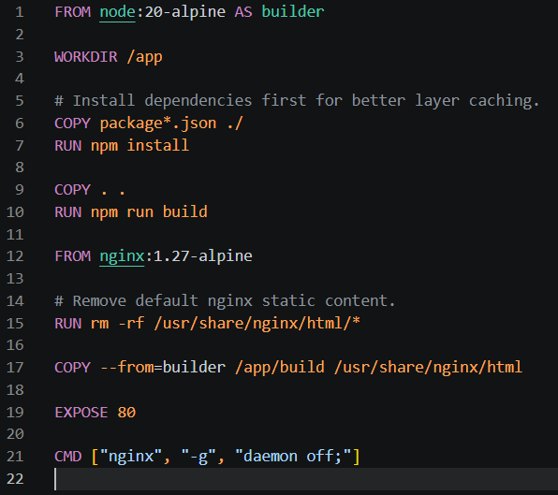

- Line number 01, AS builder means this stage name is builder
- Line number 03, Sets working folder inside container
- Line number 10, This creates React production build
- Line number 12, Instead of Node.js, now it uses Nginx web server. This keeps image smaller
- Line number 15, Deletes default Nginx welcome page files. Normally Nginx shows: Welcome to nginx. (This removes that.)
- Line number 17, This copies built React files from first stage. From /Client/build
To: /usr/share/nginx/html (This is Nginx’s website folder) So Nginx now serves your React app
- Tells Docker: This container uses port 80. That is HTTP default port.
- Starts Nginx - daemon off means: keep nginx running in foreground because of Docker needs one main process running. So, container stays alive
(Simple with daemon off terminal is showing nginx running, by default nginx running in background and terminal is free. Its not suit for this because container want to see at least one running process, so with daemon off fix this, this ensure nginx running on foreground and do not go to background)

- After client docker file I created docker file for server
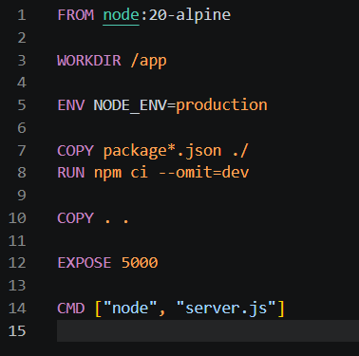
- Line number 5 Sets NODE_ENV to production. This tells Node & packages like Express that you are in production mode
- npm ci = clean install based on package-lock.json
- --omit=dev = skips devDependencies (only installs production packages). This keeps the image smaller and lean for production.
- Line number 12, Tells Docker that your app will use port 5000. This does not publish the port to host automatically; just informs Docker.

- After I create a docker-compose.yml file
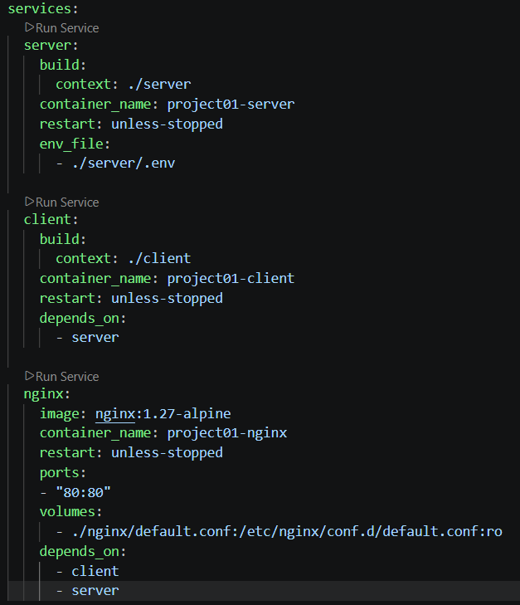
- restart: unless-stopped means Docker will automatically restart the container if it crashes, But won’t restart if you manually stop it.
- in nginx server volumes section means, Mounts your local Nginx config file (./nginx/default.conf) into the container
- :ro = read-only (Nginx can read it but not change it)
- This allows you to customize Nginx behavior (like proxy to your backend/frontend)
- After I hide this ports using env file, I created env file on root folder and type NGINX_HOST_PORT=80
NGINX_CONTAINER_PORT=80
- Then I change docker compose
ports:
- "${NGINX_HOST_PORT}:${NGINX_CONTAINER_PORT}"

NGINX Configuration

- Finnaly I created default.config file in the ngix folder
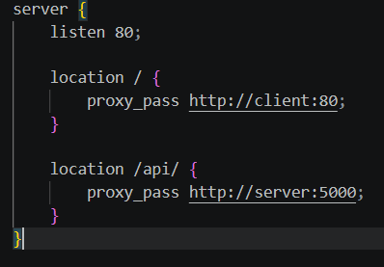
- This starts one server block. Think of it like one website rule set
- Nginx listens on port 80
Frontend part
- if request starts with / (example: /app | /task) send it to: http://client:80
Backend part
- if request starts with /api/ (example : /api/tasks | /api/users) send it to: http://server:5000

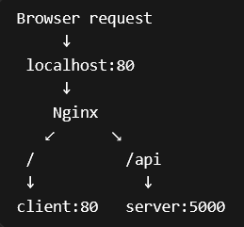
- FLOW DIAGRAME
